Find Your Next Job Now
series

How to Interview Superbly Well!
Week 4 of 9
March 9, 2023

After this session, you'll know:
- What some of the most common questions are in interviews
- How to tell your SARI stories
- General framework for the “Tell me about yourself” question

Senia Maymin, PhD
senia@senia.com
https://www.linkedin.com/in/seniamaymin/
Jobsearch mailing list: http://bit.ly/jobsearch2023

Table of Contents

Where We Are 3
Today’s session on Interviewing 4
1) The Most Common Questions in Interviews 4
2) SARI Stories 5
3) The “Tell Me about Yourself” Question 9
YOUR ACTIONS BETWEEN TODAY AND NEXT WEEK 10
YOUR NOTES 11
What we did in previous sessions 12
Session 1 - 3 Tools 12
Session 2 - Flipping the Job Search on Its Head 12
Session 3 - Connecting 12
How to Get More Info on the #JobSearch2023 Series 13
How to get on the mailing list - we send ALL updates here 13
Are the sessions recorded? Yes, here are the recordings 13
Most sessions have a workbook 13

Where We Are
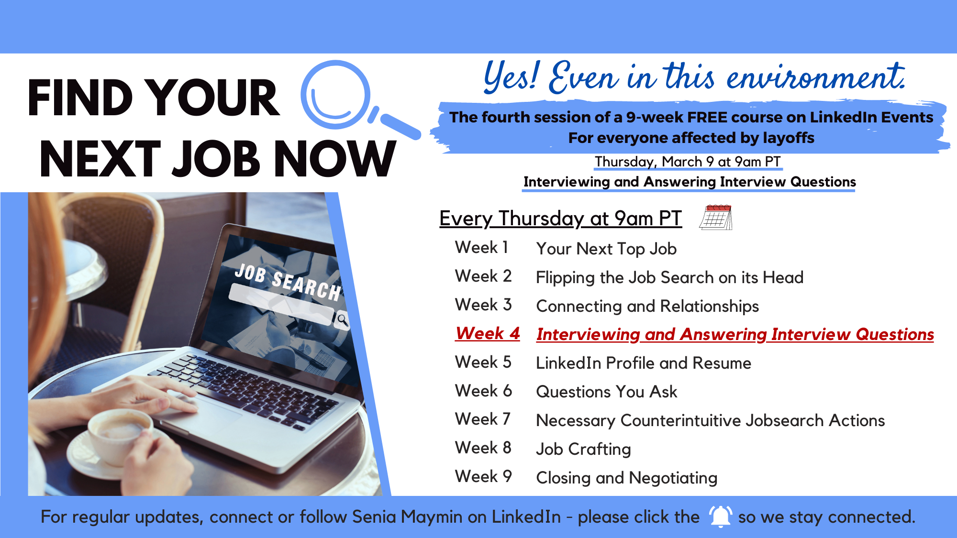

Today’s session on Interviewing

1) The Most Common Questions in Interviews

- Tell me about yourself

- Behavioral Questions
- What is a challenge you faced, and how did you handle it?
- See these from Indeed
  - Can you give me an example of a difficult problem you solved at work? How did you go about reaching a solution?

When we were launching this new product - XT Select, sales didn’t know what configuration to use. So, I created a catalog and put it on our internal website.

  - Tell me about a time when you made a mistake. How did you handle this experience?
  - Please share a time when you faced an unexpected challenge. How did you overcome this challenge?
  - Tell me about a time when you had a task to complete with a tight deadline.

- The “Who?” Method - “A Method”
- Summary of the “Who?” book is here
- Screening interview
  - What are your career goals? What would you like to be doing in 5 years?
  - What are you really good at professionally?
  - What are you not good at or interested in doing professionally?
  - Who were your last five bosses, and how will they each rate your performance on a 1–10 scale when we talk to them?

- “Who” interview for the last few roles:
  - What were you hired to do?
  - What accomplishments are you most proud of?
  - What were some low points during that job?
  - Who were the people you worked with?
  - Why did you leave that job?

2) SARI Stories - start with what was the problem and how you solved it
[Practice 2 sentences using SARI]
Build up: What was it like before you joined the company?
Ex: the organization I joined had an interesting product, but they were pivoting. They didn’t have the expertise and it was extremely niche. So, they needed to grow rapidly and hire talent in secrecy…

SARI and STAR is similar
S (Situation)- XT Select
A (Actions I took)- Worked with cross functional teams
R (Results I delivered)- 3x in bookings
I -

- Led a large cross-functional team to identify 2-3 products with an estimated incremental revenue of $150M over 5 years.
- Led a large cross-functional team to identify 2-3 products with an estimated incremental revenue of $150M over 5 years.
- Created cross-departmental strategies to address scaling regulatory risk for a multibillion dollar loan portfolio, including both customer level mitigations and systemic approaches to compliance oversight and dispute resolution.

Example (don’t use “we”, use “I”)
S - There was a team that was technologically strong. But, they didn’t have the expertise to bring in revenue. They had a great vision, but no idea on how to execute.
A- I ensure relationships with World bank, UN were built at the highest levels of the company so that they could fund and implement…..
R- Closed Partnership deals resulting in 3x revenue

Link here to details about the SARI method.

Write down one of your results:
A situation in which you
- Increased profit (i.e. increased revenue or decreased expenses)
- Improved productivity / effectiveness

________________________________________________
________________________________________________
________________________________________________
________________________________________________

What metrics can you include?
Is there a clear BEFORE and AFTER?

Write down the situation before you stepped in to solve it.
Be as dramatic as you want to be.
What was the real problem?
What was hurting the business?
What had others not been able to accomplish?

________________________________________________
________________________________________________
________________________________________________
________________________________________________

Write down the actions you took:
Specific actions (not more than three).
Action YOU took, not your team took

________________________________________________
________________________________________________
________________________________________________
________________________________________________

Was there an interesting thing?
_BTW,manufacturing and everyone else started using this catalog as their source of truth_______________________________________________
__The key people I brought on became an equity holder. Over time,it was fun to diversify the growth and relationships on a base level
_____________________________________________
________________________________________________

Put it all together

“The situation was:
- ___
- ___

The actions I took were (3 actions I took):
- ___
- ___

The results were (include metrics if you can):
- ___
- ___

By the way, an interesting thing that came out of this was:
- ___”

Mini Challenge for You

This week: Update your LinkedIn Profile with an image.

Last week: Update your LinkedIn Profile with this format:
- For ____________,
- I ____________
- to get these results ____________________
- by ____________

3) The “Tell Me about Yourself” Question

- All roads point to this role
- Ask the opening question:
  - “Could I ask you a few questions for context before we start?" [This will help you understand the hiring manager's perspective and what they're looking for in the role.]
  - "WHAT IS MOST IMPORTANT TO YOU IN TERMS OF WHAT THE PERSON IN THIS ROLE WILL BE DOING? WHAT WILL HELP YOU THE MOST?"
- Use your “Tell Me about Yourself” answer to:
- Give a one-sentence overview of yourself
- Start 5-10 years ago
- Give some brief examples of what the person will most need (that you learned about from ___________)
- End by describing how your prior roles have definitively led you to this role at this time

YOUR ACTIONS BETWEEN TODAY AND NEXT WEEK

What is your ONE TAKEAWAY from today?

Three Actions

- Health (choose one of the below - yes, one, dear high achievers!)
  - Your sleep action
  - Your exercise action (suggested 30-5-5-5-5)
  - Your water intake and nutrition action
  - Your mindfulness action

- Your incremental action on your job search - the new action
MINI CHALLENGE: Update your LinkedIn Profile with an image
MINI CHALLENGE: Practice 2 SARI Stories with a friend (buddy system)

- Your connection action
Who do you want to have coffee with?
Go for a walk with?

YOUR NOTES

What we did in previous sessions

Session 1 - 3 Tools
- Co-create more effective interviews
- Demonstrate collaboration and confidence implicitly
- Decrease the feeling of stress
- Reach out to people

Session 2 - Flipping the Job Search on Its Head
- Take on a consultant mindset when looking for a job
- Find specific people to reach out to
- Really explore your next role
  - Want - Wish - Boundaries
  - GPS for the role (Location, Industry, Role)

Session 3 - Connecting
- How to position WHO you are
- How to offer what THE PERSON may be interested in
- How to NOT LOOK for a job while looking for a job
- How to reach out via email

How to Get More Info on the #JobSearch2023 Series

How to get on the mailing list - we send ALL updates here
http://bit.ly/jobsearch2023

Are the sessions recorded? Yes, here are the recordings
There are nine sessions: Thursdays at 9am PT (Feb 16, 2023 - April 13, 2023).
For previous sessions, here are the links to the recordings.
For upcoming sessions, here are the links to participate on those dates.
- Session 1 - February 16, 2023 - RECORDED
- Session 2 - February 23, 2023 - RECORDED
- Session 3 - March 2, 2023 - RECORDED
- Session 4 - March 9, 2023 - this one LIVE on Zoom
- Session 5 - March 16, 2023
- Session 6 - March 23, 2023
- Session 7 - March 30, 2023
- Session 8 - April 6, 2023
- Session 9 - April 13, 2023

Most sessions have a workbook
- Session 1 has no workbook
- Session 2 workbook - bit.ly/jobsearch2023_week2
- Session 3 workbook - bit.ly/jobsearch2023_week3
- Session 4 workbook - bit.ly/jobsearch2023_week4
- …
- [next ones to be added]

